**Create a RDS Database, Add a table using MySQL Workbench and Take a Snapshot and share to another AWS Account**

**Step 1: Create a database name it as database-2**

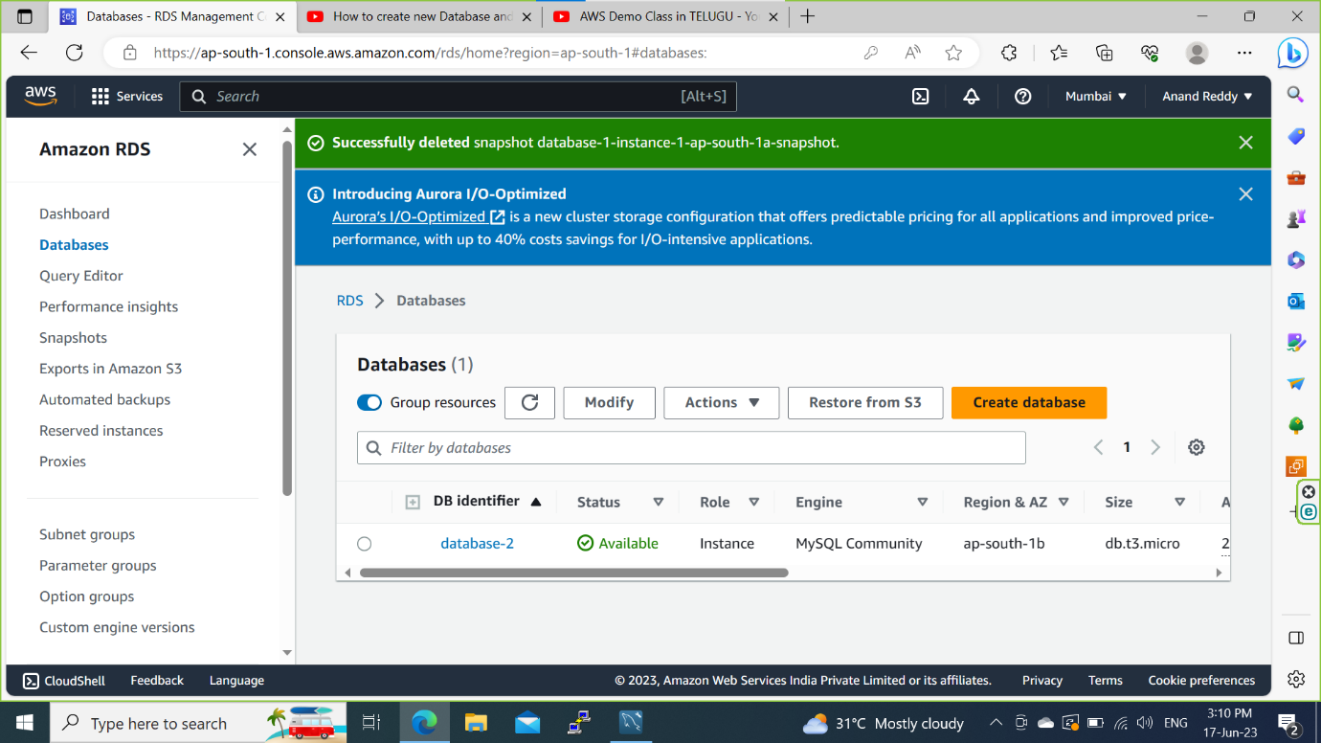

**Step 2: Connect to Workbench and create a Shema name it as Anand_Reddy**

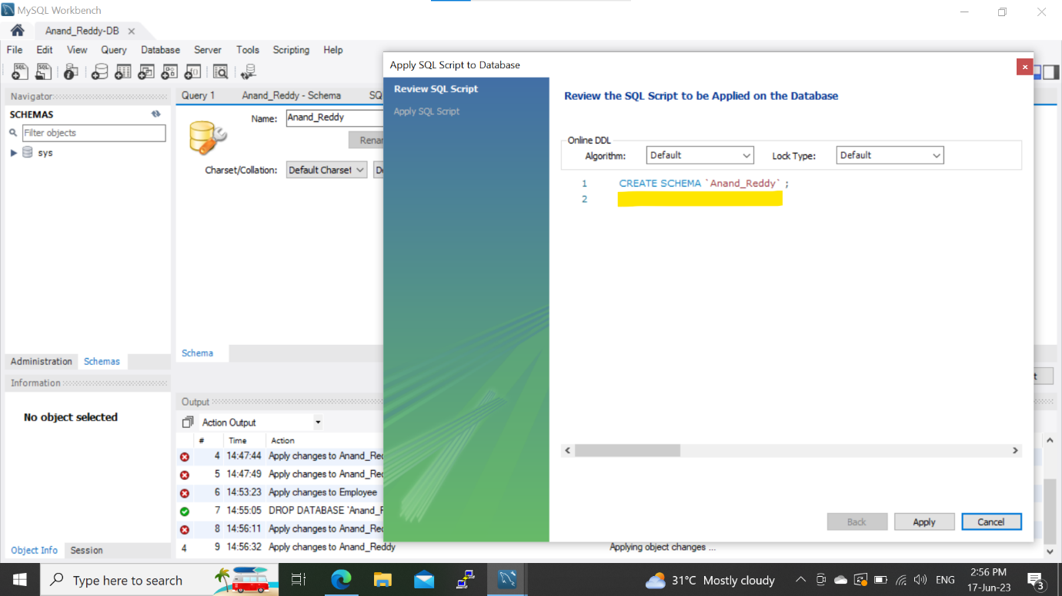

**Step 3: Create a Employee table and save it.**

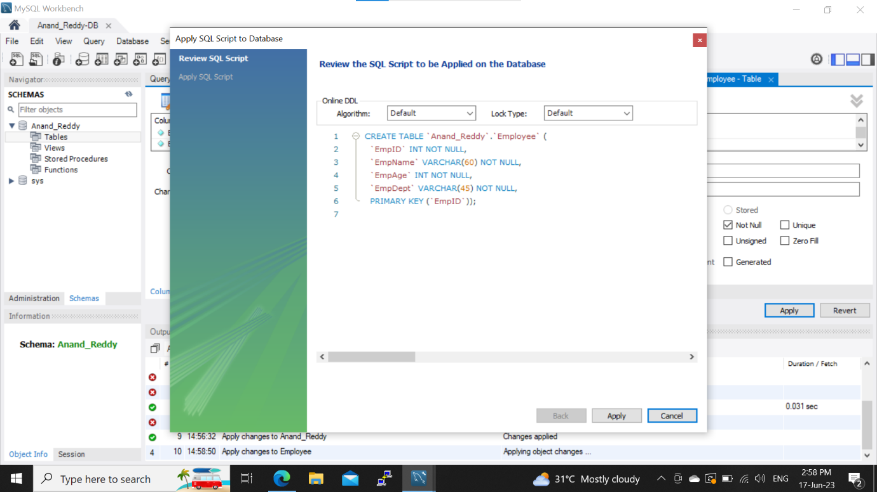

**Step 4: Add Data into the table.**

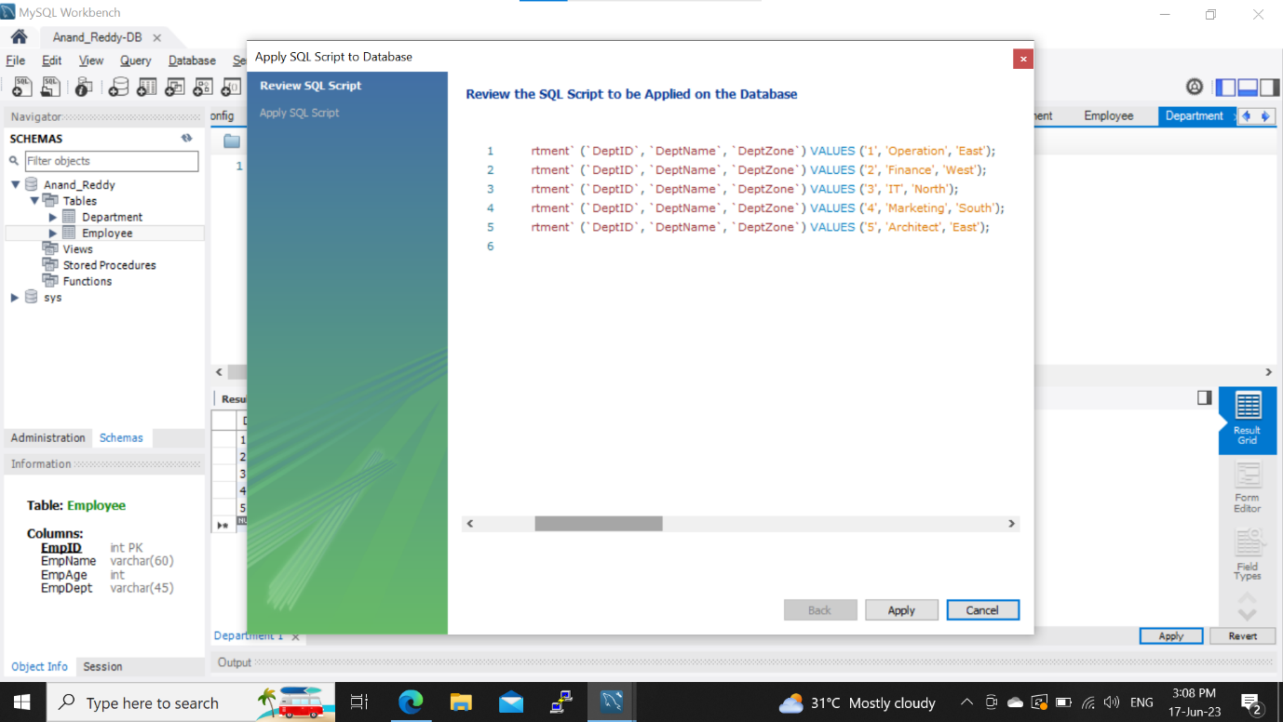

**Step 5: Create a EC2 Instance and configure a security groups for both RDS and EC2**

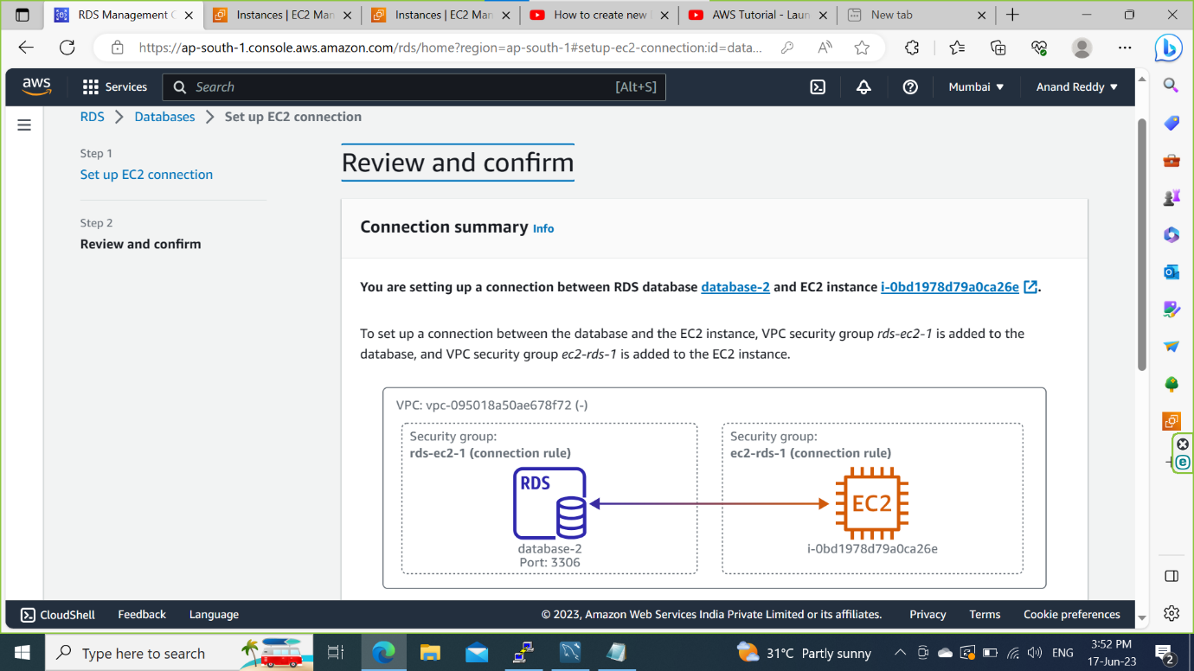

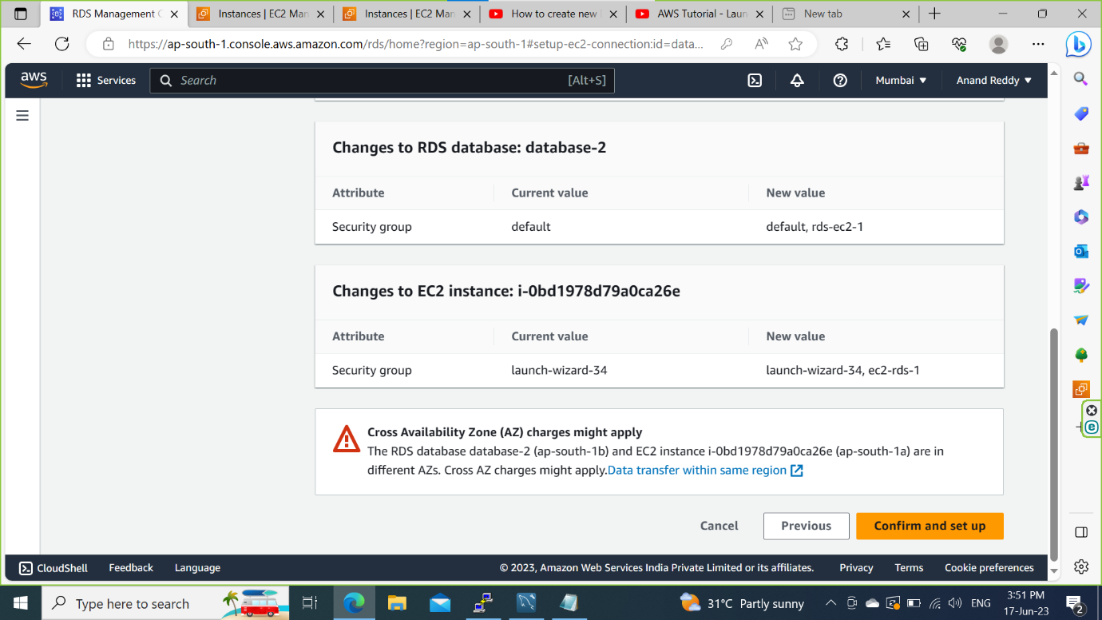

**Step 6: Take a Snapshot of database-2**

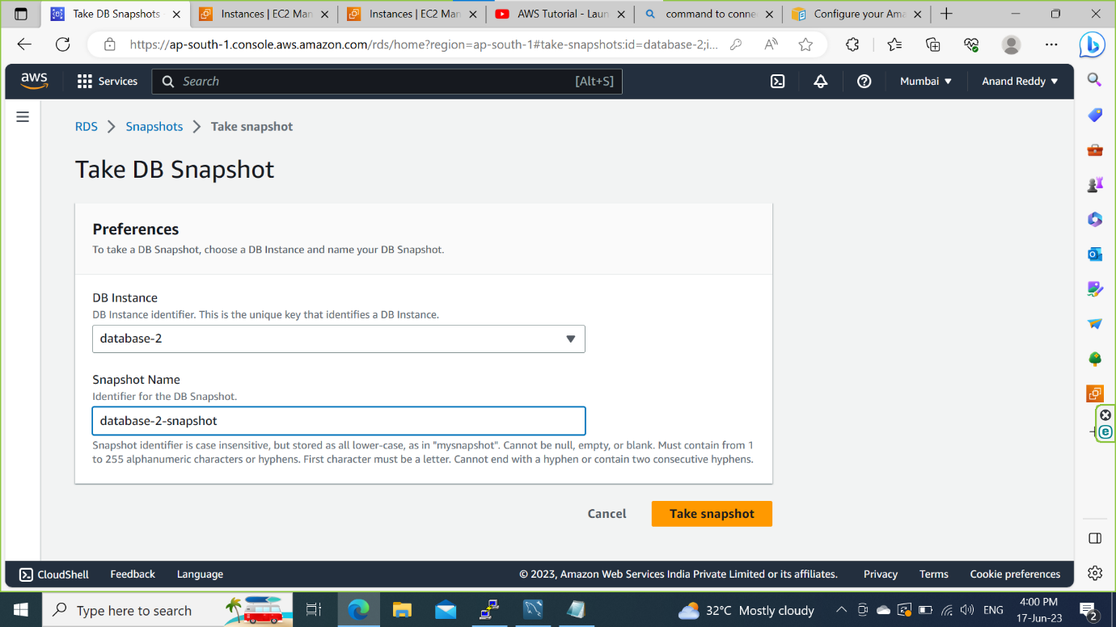

**Step 7: Share a Snapshot to different AWS Account.**

